Project Description
1 Background 1
1.1 Networking of Computation Intensive, Autonomous, and Remote Services 1
1.2 Networked Collaboration with CHAIMS 4
1.3 Remote Services in Bioinformatics 7
1.4 RiboWEB: a Bioinformatics Workbench for Ribosomal Structure Modeling 8
2 MegaGeneS Research Plan 10
2.1 Applying CHAIMS to Services in Bioinformatics 10
2.2 Incremental and Graphical Megaprogramming 12
2.3 Awareness of Processing Costs 13
2.4 Benefits from MegaGeneS 14
3 MegaGeneS Project Organization 16
3.1 Appropriateness for KDI 16
3.2 Roles of Project Personnel 16
3.3 Results from Prior NSF Support: Russ Altman 17
3.4 Results from Prior NSF Support: Gio Wiederhold 18
3.5 Performance Goals 20
3.6 Management Plan 21
3.7 Dissemination of Results 21
3.8 Institutional Commitments 22

Background
The distinguishing feature of this proposal is that we deal with knowledge in procedural, computational form, provided by remote sources. Many Artificial Intelligence programs in the past have derived power from procedural attachments. Our proposal scales this concept to deal with computational modules that are available remotely, as over the Internet. Traditional integration of remote sources has been targeted at integrating databases, our focus is the integration of remote procedural knowledge sources.

Networking of Computation Intensive, Autonomous, and Remote Services

Remote Services
A traditional architecture for a system that supports decision making or the computation of new knowledge is to have one or several databases that provide the necessary data to compute on, and an application that does the computation and provides the desired new knowledge. In more complex cases, the information comes from many sources within the same organization and even from other organizations, requiring remote access to the servers hosting the databases as seen in Figure 1. Although the data sources are remote, the computational modules ‘a’, ‘b’, ‘c’, ‘d’ and ‘e’ are local. The domain experts at the client side have to develop these computational modules themselves which requires from them processing knowledge that is typically algorithmic. Such processing knowledge is often not simple to develop; in fact, much effort is put into development and research of better processing algorithms for various knowledge domains. There is, of course, the alternative of reusing and obtaining existing computational modules by acquiring them from some provider. Yet the tasks of composing and integrating unknown codes locally into a client-side application is very technically challenging and still needs far too much internal knowledge about the components to be integrated.
Knowledge, be it encoded by data, rules or processes, must be maintained to keep its value. For computational modules, the task of maintaining them is at the site where the modules reside. Bringing information about algorithmic and procedural changes to the clients’ sites is very cumbersome. Furthermore, maintaining the modules requires intimate knowledge about the processing domain and about the components themselves, knowledge that is readily available to the experts who have developed the components, but should not be required from the end-users composing and integrating them.
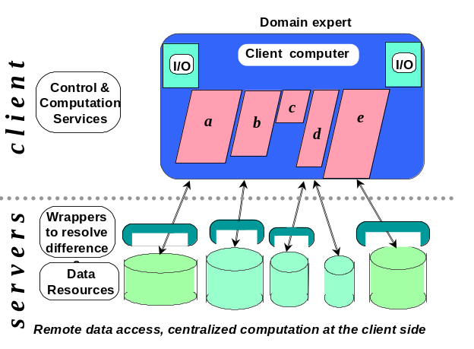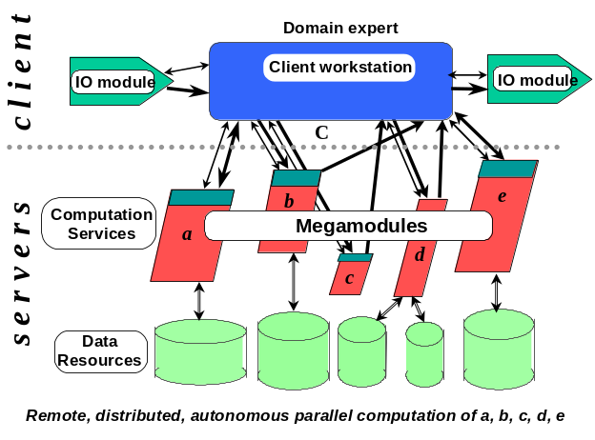
Figures 1 and 2: Database services supporting local computational components (left)
versus remote computational services (right)
Figure 2 shows a completely different approach: instead of accessing databases directly and incorporating computational modules locally, autonomous computational services are accessed remotely. Only their coordination and composition is done at the client’s site.
Many resources that provide computational services have emerged in the last years. These range from computational services on the web for making reservations (e.g. SABRE) to new outsourcing models for administrative applications (e.g., Oracle or SAP applications for smaller companies that cannot afford to bother with system infrastructure, administration and maintenance [Oracle:98]), and automatic remote backup systems. Work is under way to formalize functional interfaces to Web servers based on XML and http (WIDL: Web Interface Definition Language [WIDL:97]). The new standard JointFlow from the OMG and the proposal SWAP [Swenson:98] focus on specific interface definitions for distributed workflow systems. Yet having a simple access to remote services is only the first step. Just as important is to take into account the very specific nature of remote services that are autonomous and computation intensive. Furthermore, an access protocol for remote, autonomous, and computation intensive services is just the basis. Having a clear process definition for providing, composing, and using remote services, and having the tools to effectively support this process, is just as important for successful knowledge networking.

Autonomous Services
We assume that most remote computational modules are autonomous, i.e. they are provided, operated, and maintained by a different enterprise (different organization, company, department, or research institute) than they are used by, without a common supervising control authority. Autonomy of remote services brings many advantages, for the providers as well as for the clients:
- Implementation technology: A provider is free to choose whatever implementation technology is best. For instance, Fortran is still a valid language for numerical applications, but completely inappropriate for client-side computations. All implementation issues such as integration and access to underlying databases are completely hidden from a client using the service, thus freeing the client to focus on the problem domain.
- Maintenance: Maintenance is best done where the required knowledge is available, without involving the client of the services at all, or only marginally in the case of updates of the interface.
- Low entry barrier: A client does not have to buy computational modules and install them at its own site. Instead the client can just use available services remotely and perhaps pay for them on a usage basis. This has the advantage that even for computation- and resource-intensive services only a minimal infrastructure is needed at the site of the client: a capable PC and a reasonable network connection may be adequate. Clients that make tentative or rare use of certain software packages do not have to invest to buy and install them, they can just use them as necessary. This is especially important for underprivileged research institutions that cannot afford to buy all the interesting software packages and the super computers to run them on.
- Competition: A client can sign up for various services from different providers offering similar or the same functionality, and decide on an instance basis which of them to use, based on criteria like availability, execution time, fees, or quality of results.
However, autonomy of remote services also means that a client has no direct control over the resources made available to the computational modules, and thus the client has no control over their availability and performance. When assuming autonomy, there is no central authority governing and guaranteeing these issues, in contrast to distributed systems within one organization. Therefore, new ways have to be found to give control back to the client in a non-intrusive way. As the concept of accessing autonomous remote services is emerging, new issues like control and coordination in autonomous environments are getting recognized more widely (e.g., [Ludwig:99]). Dealing with these issues is an integral part of the MegaGeneS project described in this proposal, and in its predecessor project, CHAIMS, presented below.

Networked Collaboration for the Composition of Remote, Autonomous Services
Today, we observe two approaches to the composition of remote services:
- Disparate services are, for instance, accessed with a browser over the web. Composition is done manually by cutting and pasting of results from an output window of one remote service into the input window of another remote service. Such composition is not only awkward, it also requires the composer to be present throughout the execution of the composition.
- The composition has been programmed by software engineers into a client application (typical for client applications using CORBA to access other in-house services). Programming for distributed systems requires technical expertise, and though emerging scripting languages for certain protocols (e.g., CORBA scripting [OMG:96], [Merle:98]) will allow faster turnaround in programming, the composer still has to be a good programmer and a technical expert. Also compositions programmed in these languages cannot be changed easily at execution-time.
Both approaches fall short of exploiting the potentials of remote services. They either do not support composition, or require the building of client applications by technical experts. This is only feasible for client applications that are defined once, need to be changed rarely, and are used often. The turnaround time from problem detection, problem definition, and implementation to deployment of the client application is far too long for all those situations where a domain expert wants to use remote services and define and execute a composition of these services whenever a new need arises. We therefore suggest a third approach to the composition of remote services (see Figure 3):
- A composition or megaprogramming system supports the composition of remote, autonomous services by offering an easy front-end composition language to the domain expert while hiding technical details of accessing remote services [BoehmS:92].
The domain expert (a decision maker, a scientist) who is interested in and capable of interpreting the results of the services and their composition is also the person doing the composition, i.e. the megaprogrammer writing a megaprogram. Composition is done in a simple language targeted solely at the composition of remote and large computational services, the megaprogramming language. The megaprogram expresses the process model of the composition, it can be written ad-hoc and executed immediately by the domain expert. The domain expert alternatively writes and runs megaprograms, ideally without having to wait for the help of any technical experts, thus blurring the traditional distinction between compiling and running a program.
This model leads to a new partitioning of knowledge and associated responsibilities (see Figure 3). The domain expert (as both a user as well as a megaprogrammer) is responsible for the composition and its adequacy for the problem to be solved (model view). The composition system is responsible for generating the access to the remote services. The developers of the composition system are technical experts in regards to distribution systems and the technical aspects of composition (process interaction). The providers of the computational modules are domain experts in the domain of their computational modules as well as technical experts, making their services available for general use (service views).
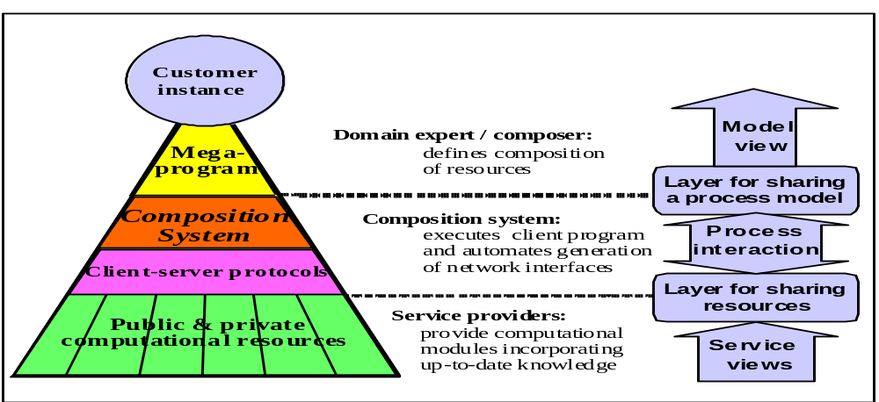

Figure 3: Networked collaboration for composing remote, autonomous services

Networked Collaboration with CHAIMS
In the CHAIMS project (Compiling High-level Access Interfaces for Multi-site Software) we have investigated the composition of remote, autonomous services by using the third approach mentioned above. The CHAIMS system consists of the megaprogramming language CLAM, the access protocol CPAM, the CHAIMS compiler, and wrapper templates that support the service provider in the task of providing CPAM compatible computational modules. Figure 4 gives an overview of the architecture.
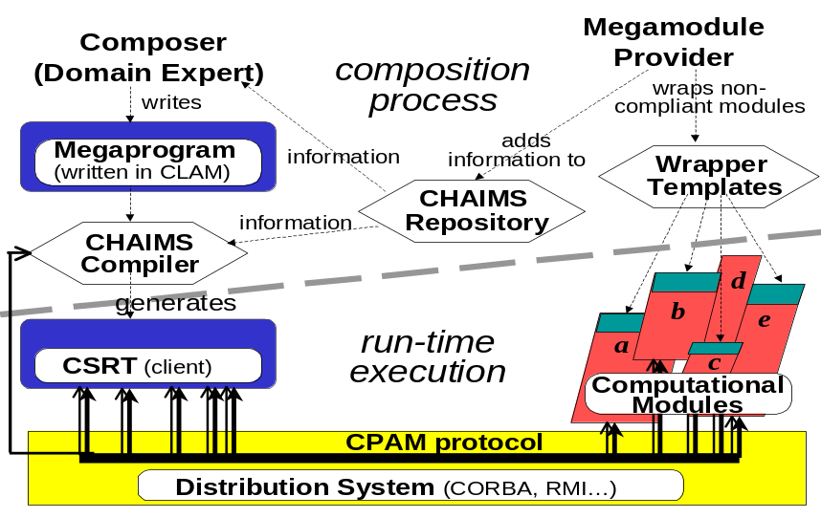

Figure 4: CHAIMS architecture

Composition Process
A service provider can take advantage of wrapper templates for providing CHAIMS compatible access to services. CPAM, the access protocol used in CHAIMS, has special primitives to offer the client more control over the execution of remote services. The wrapper templates contain the necessary technical infrastructure - management of attribute settings, of results, and of progress information - required by these primitives. Besides providing access to the services, the service providers also have to advertise their services. The CHAIMS repository contains information about the methods offered by services, the attributes required, the results provided, and also some technical information needed by the CHAIMS composition system.
The domain expert interested in composing services gets information about available services from the CHAIMS repository, and writes a megaprogram in the CLAM language. This megaprogram is then compiled by the CHAIMS compiler into the client side run time (CSRT). This compilation process goes beyond mere translation of a higher level language. The compiler also generates and adds all necessary stub-code for the remote accesses of computational modules.

CLAM (Composition Language for Autonomous Megamodules)
The CLAM language is a high-level composition language that clearly separates the computational services from managing and composing those services. It can also be viewed as an order-of-magnitude scale-up of object-oriented principles. All computation is performed by computational modules that are either remote services or local modules. Even I/O, user interface and simple arithmetic are delegated to special computational modules that are composed with CLAM. The language CLAM only consists of the basic CHAIMS primitives seen in Figure 5, plus some control instructions. The language is freed of any technical details for the access of remote services over distribution protocols. These details stay hidden from the domain expert. The CHAIMS compiler, and thus the developers of the CHAIMS compiler, are responsible for adding them to the generated client side run time.
Constraining the language CLAM to composition allows us to have a simple language while introducing more flexibility for composition. Having separate primitives for setting up a connection to a computational module, invoking methods of the module, and extracting results from the module, gives the composer more control. It also has enabled us to add primitives that allow optimizations that are specific to the use of remote services. These primitives estimate the cost of a method prior to invoking it, preset parameters that are needed by more than one invocation so these parameters do not have to be set and retransmitted with each invocation, examine the progress of an invoked method, and ask for the availability and quality of results before they are extracted.

Besides invoking methods and extracting results, the basic CHAIMS primitives also allow clients to choose the best suited computational module at run-time, based on availability, performance and cost functions. They allow to terminate and to reschedule invocations based on progress information. And they support incremental extraction of results (progressive extraction of lower-quality results as well as partial extraction of some of the results when others are not ready yet). The primitives are also the basis for further work we will be doing in optimizing megaprograms by exploiting the inherent parallelism between remote computational modules and by scheduling invocations at run-time automatically.
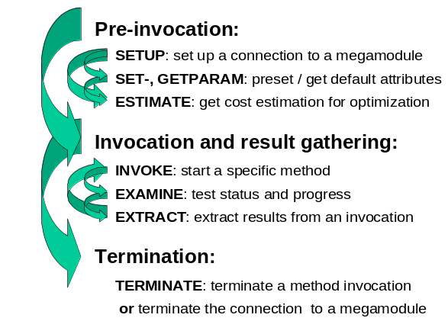
Figure 5: Basic CHAIMS Primitives

Various coordination languages, template classes and code generation systems (e.g., Manifold [Arbab:93], Linda [Carriero89], and its extensions like Objective Linda [Kielmann:96] and Jada [Ciancarini:94], HADAS/ISL [Ben-Shaul:97], Regis/Darwin [Magee:94], Polygen [Callahan:91]), address the issue of composing distributed software. The main difference to the approach in CHAIMS lies in the assumption of autonomy. In CHAIMS, we do not require changes to the legacy code by the composer; the composer has no access to files, CPUs or OS-commands on the remote systems, and the composer has no control on availability and resources. We address the composition of services provided by independent service providers, separated from the composer by legal, organizational, and technical boundaries. This is a newly emerging issue in a world of total connectivity, yet a very important requirement to be dealt with in order to make effective usage of today’s possibilities of collaboration concerning computational knowledge.

Run-time Environment
As shown in Figure 4, the compiled megaprogram, also called the client side run time, communicates at run-time with the computational modules by using the CPAM protocol on top of one or more of several distribution systems. The CPAM protocol also contains the basic CHAIMS primitives shown in Figure 5. Depending on the distribution system used, these primitives are either procedure calls (RMI, CORBA, DCE) or request and response messages (plain TCP/IP, HTTP). This approach enables us to easily replace one distribution system with another one, depending on the actual need of specific CHAIMS implementations. This takes into account the concept of autonomy of modules, allowing not only heterogeneity concerning implementation languages and operating systems, but also supporting heterogeneity in distribution systems for the remote access to the computational module.
Middleware systems like CORBA or Java RMI provide the possibility to connect to remote objects and to make remote procedure calls. In contrast to CPAM, their focus is not the integration of autonomous services, thus they do not specifically address the challenges arising from autonomy. Java RMI can only access Java sources, CORBA only accesses sources in languages for which OMG provides a mapping and vendors sell ORBs. Client programs are traditional programs coded in C, C++ or Java. They neither offer a higher-level composition view as is the case with the CHAIMS composition language or other coordination languages, nor do they have features like incremental programming or incremental result extraction.

Current Results
Within our current research funded under the DARPA EDCS program we have defined the basic CHAIMS concepts and architecture, the CHAIMS megaprogramming language CLAM, and the CHAIMS access protocol CPAM. We also have developed a basic infrastructure with a composition wizard that allows a composer to easily write, compile, and execute megaprograms, and a repository browser visualizing the CHAIMS repository. The research work in the context of the CHAIMS project has allowed us to gain experience with the approach of CHAIMS to composition, and has helped us to identify important new issues like incremental result extraction, incremental programming, and the application of cost-functions and cost-estimation during compilation as well as execution. Further exploration of these issues and their application to a significant area is the essence of this proposal.
We have published various articles [PerrochonWB:97], [TornabeneJW:98], [BeringerTJW:98C], [BeringerTJW:98L], [ChavezTW:99], [BeringerW:99a], [BeringerWM:99b], [MelloulBSW:99], [SampleBMW:99], and we have set up two web demonstrations based on the CHAIMS concepts. These, as well as the description of most of the components of CHAIMS, are available on our website (http://www-db.stanford.edu/CHAIMS).
The concepts that lead to CHAIMS and MegaGeneS are grounded in earlier research. Research on knowledge-based systems, supported by ARPA/DARPA since 1977, provided the foundation (i.e., [ElMasriW:79], [DeZegherEa:88], summarized in [WiederholdEa:88]). The scalability of the object-oriented paradigm for multiple clients was investigated in [Wiederhold:86v] and led to a major project, funded by NLM, to automate the creation and updating of objects from relational databases [BarsalouSKW:91], and the underlying technological results are now integrated in various commercial systems, including SunSoft’s DOE [KellerJA:93]. Later work dealt explicitly with heterogeneous information sources and provided experience leading to the MegaGeneS research proposal [Wiederhold:92a], [AgarwalKSW:95], [WiederholdWC:92]. [Wiederhold:98D] summarized the commercial aspects of the new technology.

Remote Services in Bioinformatics
The domain of bioinformatics is an attractive target application area for our CHAIMS technology. Bioinformatics is the emerging discipline of using information technologies to store, retrieve, analyze and display biological information. There are numerous new experimental methods in biology that collect information on a scale much larger than was previously possible, including genome sequencing, "gene-chip" DNA arrays, large scale structure-determination efforts and others. The immense growth of biology has created a new industry of professionals who can make sense of the data. The data, however, is stored in numerous databases which are associated with special purpose tools that are continually being updated or replaced by new algorithms. The primary repositories are Genbank (DNA data), Swiss-prot and PIR (protein sequence data), PDB (macromolecular three-dimensional structure), Cambridge crystallographic database (small molecule three-dimensional structure), and Medline (published biomedical literature), but there are many other data repositories which add value to these core databases, including OMIM, a database which relates basic biological sequence information to human disease.
It has been clearly recognized for the past few years that the challenge of integrating these databases is significant. A number of data-oriented integration technologies have been created using integration models as well as federation models, including BioKleisli [BunemanDHOW:95], SRS [EtzoldA:93], OPM [MarkowitzCKS:97], KEGG [Ogata:99], Entrez [SchulerEOK:96] and other approaches. The ESPRIT project with EBI, SmithKline-Beecham and Synaptic in Greece, works on data replication in CORBA. There has been much work on linking these information sources using advanced database technology. The integration of services provided on top of these database integration engines has not yet been sustained. There are the partial incorporation of BLAST into OPM at Lawrence Berkeley labs, GENSPAN, and similar single point efforts in many dispersed research groups. Another effort has been the development of bio-widgets [Searls:98] for information visualization. A bioPERL consortium has been formed to encourage the development of a common platform for delivering both data structures and a standard API for algorithms. Work for facilitating general access to services in bioinformatics is also under way in the Life Sciences Research Domain Task Force of the OMG. Yet this work is limited to specifications at the protocol level using the CORBA architecture. The scope of the results, their adoption by service providers, and their ability to meet all the various requirements of accessing as well as composing remote services that are autonomous and computation intensive has yet to be seen.
Typical of most bioinformatics applications is the flow of information from one algorithm to another as it is processed from raw form to highly processed. For instance, a raw DNA sequence is digitized by the experimental apparatus. The digital data is processed by an algorithm that assigns one of the 4 DNA bases to each position in the sequence. The raw sequence is checked for errors by another module. The checked sequence is then scanned for features of interest, including the start/stop of genes, the presence of signature subsequences that indicate function, and multiple other analyses, including the translation of the DNA genetic code into the protein amino acid code. The protein sequence can then be processed, looking for known motifs, aligned with other sequences, and perhaps even used to make a prediction of 3D structure (a difficult task at this time). The sequence can be used to establish relationships to other (better characterized) sequences, and the medical literature on these well-characterized sequences can sometimes be used to predict structure or function. The resulting 3D structure is analyzed to look for unrecognized functions that emerge in three-dimensions that were hidden in the sequence. Candidate drugs can be docked to the putative structure, and their affinity can be predicted as chemists decide whether a new drug is a good candidate for development.
Throughout this process there is information flow to be managed from one computational module to another. Often iterations are needed among the computational modules while false leads are being eliminated. Eventually, results of the investigations are used to drive further bench or pre-clinical investigations. Many of these analyses can proceed in parallel, and be initiated as soon as partial information is available. The bio-scientist understands these interactions, but today does not have a tool for flexible composition and control at a reasonably high level.

RiboWEB: a Bioinformatics Workbench for Ribosomal Structure Modeling
Our application focus in this work will be on the RiboWEB system. RiboWEB is a knowledge-based system to support the creation of three-dimensional models of biological macromolecules. In particular, RiboWEB is built to support modeling of the important cellular organelle, the ribosome (a large ensemble made of nearly 100 individual molecules, and comprising over 100,000 atoms). RiboWEB is delivered on the web to enable sharing of data and collaborative model-building over the internet, and uses a structured representation of experimental biological data as a standard method for communication. RiboWEB is built in the application shell, OWEB. OWEB is an environment for allowing the publication of scientific data on the web, and the creation of modules to analyze this data, communicate the results of the analysis to colleagues over the web. OWEB is composed of three components: the knowledge base, the user interface, and the computational modules. The instantiation of OWEB with ribosomal data and molecular modeling modules is called RiboWEB. Additional information as well as a demo of the knowledge base can be found at http://smi-web.stanford.edu/projects/helix/riboweb.html.
The RiboWEB knowledge base is a frame-based representation system that represents a standard terminology for structural modeling as well as experimental structural biology. It is based on ontological models of physical objects, experimental data, reference information and organisms. Thus, a set of names for standard molecules is provided, as well as (most importantly) a set of templates for representing the outcomes of about 30 prototypical experiments that can be performed on a biological molecule in order to gather structural data. These 30 prototypes are sufficient to represent nearly 200 articles that report primary experimental data relevant to the task of modeling the ribosome. Each of these articles is now represented in the RiboWEB knowledge base which has about 200 concepts, 200 relations and a total of nearly 15,000 individual encoded observations. In RiboWEB, the knowledge base is used as the common block (or blackboard) shared by all computational modules and used as a highly structured "clip board" for transferring information. All activities by a user start with a READ of information from the knowledge base, and end with a WRITE of new information to the knowledge base.
The RiboWEB user interface supports user login on the web, authentication, and tracks user sessions so that they can maintain state and be resumed at any time.
The RiboWEB library of computational modules is a set of legacy codes that are gathered together into the RiboWEB system to allow investigators to apply these codes to the data contained in the knowledge base. In order to bring a computational module into RiboWEB, a wrapper must be written which accesses the necessary data from the knowledge base, formats it for input into the legacy code, runs the code, and then reformats the output of the code for storage in the knowledge base. The inputs and outputs of a computational module are stored in a "methods ontology" that organizes information about the available methods, their required inputs, their computed outputs, and other metadata about these computational facilities. A user can pick just one computational method at a time as shown in the left screen shot of Figure 6. For this method the user then chooses the input parameters as seen in the right screen shot, yet no composition is possible. Currently, all computational modules must run on a single machine, and have access to the knowledge base as a common communication platform. It would be very desirable for computational modules to run in a more distributed fashion, and to have data from the knowledge base be augmented with data from other sources as valid inputs to these modules.
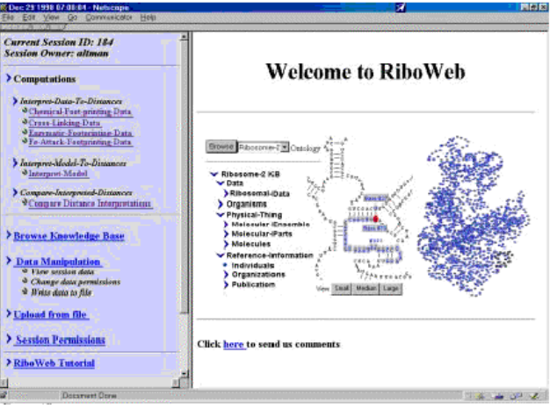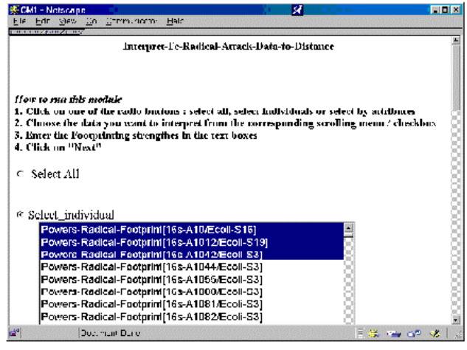
Figure 6: RiboWEB
The scenario for use of RiboWEB is that an investigator logs into the system, selects some experimental data of interest, and runs a first module to interpret this data into distances usable by 3D structure reconstruction algorithms. A second module is then run to select elements of the molecule to be modeled, as well as the level of representation for these elements (full atomic vs. reduced detail representations, for example). A third module is then run to compute a 3D layout of the elements based on the interpreted data. A fourth module compares the 3D model with other elements of experimental data for validation. A fifth module may be invoked to display and report the final structure to a colleague over the internet. Iterative application of these scenario leads to models that improve because the interpretations of the data improve, the use of the 3D modeling software improves, and the match to existing data sources is optimized.
Thus, RiboWEB essentially is an architecture for invoking local computations using a common data structure. It represents an excellent test bed for the CHAIMS technology because its current architecture limits its scalability. In particular, CHAIMS could add the following features to RiboWEB: ability to invoke remote computational modules on remote computational platforms taking into account the autonomy of service providers (and its consequences like lack of control and heterogeneity), the ability to monitor computations and abort them if they are clearly not cost-effective, the ability to create "macro" modules or module compositions in which a sequence of computational modules are grouped together to provide reusable computational sequences, and the ability to dynamically monitor and change these sequences while they execute.

MegaGeneS Research Plan

Applying CHAIMS to Services in Bioinformatics

MegaGeneS: Dynamic Mega Networking of Genomic Services in OWeb
We will apply the concepts and tools of CHAIMS to the OWEB environment. OWEB provides an ontology for computational modules and supports the invocation of these modules. Yet currently all of these modules are local, they can only act on data available in the data ontology, and the results are always stored in the data ontology. Modules are invoked manually, there exists no composition or scripting language that would allow composition of several modules and there is no system that would control their composition at run-time. Thus there are also no concepts of optimizing a composition. Neither pre-invocation cost estimation nor presetting of parameters are offered. Also progress monitoring and incremental result extraction are not available. When moving to using remote services offered by remote autonomous computational modules, these features will become essential, especially as many of the computations done in the context of bioinformatics and genomics are computation and resource intensive. Execution times can easily be several hours, or in worst cases, even days. Yet many of these methods could deliver preliminary results that could be used for optimizing computation time, if an appropriate access protocol backed by an appropriate composition system were available.
Using and extending CHAIMS for OWEB will not only verify the current CHAIMS concept and advance the CHAIMS concepts and tools in various aspects, it will complement OWEB with the features needed for transforming OWEB into a tool bench for scientists covering both data as well as computation.

Access to Remote Services
We will introduce the CPAM protocol into OWEB, and integrate a client engine into the OWEB system. The client engine will be derived from the current CHAIMS compiler. Yet we will slightly modify the generation process in order to also support incremental composition. Like the CHAIMS compiler, the client engine will take care of the generation or integration of stub code and other technical aspects for accessing remote services, thus completely shielding the composer from any technical details concerning distribution systems. The molecular modeler should not have to deal with aspects not directly related to the biological domain.
We will have to investigate which distribution systems will be most appropriate. We might choose plain TCP/IP to start with as it offers all necessary transportation features, combined with XML for the structuring of the messages and the definition and encoding of data. CORBA requires much overhead that we might not take enough advantage of, at least not in the first versions of MegaGeneS. RMI is focused very strongly towards Java, and JNI-bridges to other languages so far have been limited to C and C++, but many of the legacy computation modules we will integrate are in Fortran, LISP, Perl or other languages that are difficult to integrate into third generation languages. Other possibilities are SWAP, a proposal for a simple workflow access protocol that also uses XML for data, another http-based protocol, or one of the proposals for an OMG-protocol for life-sciences. Currently much is going on concerning access protocols for remote services and more is to be expected. Due to the separation between the higher-level CPAM protocol and the underlying distribution system, and the fact that we already implemented CPAM on top of several distribution systems, we will be able to defer that decision to quite a late point. We are also able to use one distribution system in a first version, and then change to another one as we need more features or some of the proposals become standardized and effectively adopted.

Module Repository
The CHAIMS repository corresponds to the methods ontology in OWEB, as they both store meta-information about the capabilities and requirements of the computational methods. Both fall short of fulfilling the requirements of an environment with several autonomous service providers. Before remote services can be added to OWEB, the requirements for the module repository need to be clarified and a suitable architecture as well as process have to be defined. Is there one central repository or does each provider have its own repository that will be merged into a temporal central repository when a composer uses OWEB to program a composition? What is the deployment process for repositories and repository information? Who has the responsibility and the right for making new entries and updates into the module repository, taking into account autonomy of providers as well as accuracy and security of the repository? How will versions of services be handled? Implementation of the repository could be a text file, e.g. using XML as mark-up, or it could be implemented by using directory standards like JNDI or LDAP. For a good acceptance of OWEB in the research community, it will be important to involve prospective service providers and composers from the beginning when clarifying the requirements for the module repository.

Test-cases: RiboWEB and DNA-CHIPweb
RiboWEB, the most completely developed OWEB system, will be the main test case for MegaGeneS. RiboWEB has an active user community, with collaborators in UC Santa Cruz (Noller), U. Alabama, Birmingham (Harvey), and The Scripps Research Institute (Case). There exist remote computational modules that should be integrated into RiboWEB, and there is also the interest from both prospective module providers as well as prospective users to have remote computation modules and a front-end for effectively composing and controlling them. The enhancement of RiboWEB by a composition language and tool will definitely improve its usefulness to bioinformatics researchers, and thus will give us important feedback about the concepts developed so far.
Once MegaGeneS has been successfully applied to RiboWEB, another potential test case will be a new OWEB system in a new domain within Bioinformatics. We are considering creating an online system to support computations relevant to DNA microarrays or "DNA chips." This new technology allows biologists to assess the level of individual molecules within a cell under arbitrary conditions and over multiple time points. These microarrays are revolutionizing biology, but offer a logistical problem because multiple algorithms are being proposed and compared by many groups, and the volume of data is so great that it is difficult to conduct controlled comparisons to evaluate the computational methods, as well as the results they produce. A new resource, DNA-CHIPweb, would use OWEB, but would have a different knowledge base content, and a different set of computational methods, while sharing the same architecture and OWEB infrastructure as RiboWEB. Currently several institutions are developing algorithms for analyzing DNA-Chips, including both industrial and academic laboratories. If an OWEB system can be built up for managing the emerging knowledge in that domain, the enhancement of that OWEB system with CHAIMS technology would allow it to make all the emerging computational modules available to the whole scientific community working on DNA-Chips.

Modularization of CHAIMS Components
Applying CHAIMS to OWEB will allow us to re-architecture certain parts of CHAIMS. Based on the experience we have gained so far by developing the initial concepts, infrastructure and demo examples, and based on what we will learn when adapting them for the OWEB environment, we will be able to modularize CHAIMS components in a more adequate and sophisticated way. This will allow us to adapt all or part of CHAIMS more easily for domains other than OWEB, and will facilitate the adoption of CHAIMS concepts and technology by other interested parties in academia or industry.

Incremental and Graphical Megaprogramming

Graphical Composition
Currently, OWEB does not offer the possibility to program or script a composition of methods. Each method has to be invoked individually and manually. Adding a composition language to OWEB will enable a scientist to program a planned computation that involves more than one computational module, and to execute it automatically.
CHAIMS currently offers the megaprogramming language CLAM. Though it is a simple language, for people not comfortable with programming it is still an awkward interface for doing composition. We therefore plan to add the graphical language VisiCLAM that will allow a scientist to compose computational modules by using boxes and arrows with a minimum of textual entries. For such a user interface we will be able to reuse many of the concepts found in today’s modeling systems for processes and architectures or in programming systems for JavaBeans or other GUI-components. A megaprogram in CHAIMS is a description of the process model, thus the graphical models will also represent the process models executed in a composition, bridging the gap between process modeling, process implementation, and process execution as found in many other approaches to software architecture and design.
The content of a megaprogram, be it textual as in CLAM or visual as in VisiCLAM, is closely related to the content of the module repository. In the current CHAIMS system the composition wizard for writing megaprograms and the repository browser for looking up repository entries are not integrated as much as is possible and desirable. Closer integration will be essential to ensure the easy adoption of the compositional enhancements to OWEB.

Incremental Composition: Dynamic Changes to a Megaprogram during Execution
In traditional client applications or workflow management systems, a program or process is specified, implemented, and then executed many times. Changing the program or process while it is executed is impossible. Changes in the processes would results in aborting the execution, redesigning the programs, re-implementing them, and restarting execution, including reloading all data and control knowledge. Even when, as is the case in the current CHAIMS version, the design to implementation cycle is very short and programming is done by the same person that executes the megaprogram, and thus does not lead to any delays, aborting an executing megaprogram is not always tolerable. Especially in cases where a megaprogram has been running for hours or days, a scientist should be able to make changes to it on the fly. Such an interactive capability was an important reason for the broad institutional acceptance of an early system for medical computations, which was, of course, limited to local computation [CrouseW:69].
In contrast to process models in organizations, the composition model for computational modules in scientific research is experimental and often only evolves during its execution based on results from earlier method invocations. Yet no scientist likes to lose results already computed, nor to wait until the rest of the computation that has become obsolete in the meantime is finished. Therefore it is essential to integrate into the user-interface for composing computational modules the flexibility of changing a finished megaprogram (graphical or textual) while it is executing, and to reapply any possible optimization strategies done by the compiler or client engine. While most programming environments make it hard or even impossible to add incremental composition, the basic CHAIMS concepts have been designed with incremental composition in mind, which makes its investigation and integration into MegaGeneS possible.

Awareness of Processing Costs
CHAIMS assumes that computational methods can be computation intensive, an assumption fulfilled by several of the modules used in RiboWEB. Computation intensive modules lead to high costs in resources on the side of the service provider, high fees for the client, and long waiting times before results can be extracted.

Incremental Result Extraction, Progress Monitoring
Especially in an environment where many computations are experimental yet a computational module may provide preliminary results (e.g. simulation modules), it is worthwhile to offer facilities for incremental result extraction and progress monitoring. These features are already part of the CHAIMS protocol CPAM and will be integrated into MegaGeneS.
CPAM allows clients to ask for the status and progress of an invoked method, and to ask for the availability and accuracy of specific results. If certain results are ready, these can be extracted before all other results are available. The extracted results might be used for invoking other methods, to determine the future control flow, or to decide on the termination of a method invocation before all other results have been computed. If a method provides preliminary results, these also might be extracted and used to determine whether the computation is proceeding as desired, thus avoiding hours of computation that are no longer needed because the method will have to be restarted with a slightly different set of input parameters. Also, as RiboWEB computes a three-dimensional structure using an optimization algorithm, it is sometimes useful to extract intermediate "best so far" results in case numerical instability or random search leads to less useful final results.
Monitoring the progress of an invocation enables a megaprogram or scientist to invoke more than one computational module offering similar methods, and to abort the one with slower progress after some time, or to take other actions if a computation advances too slowly. Without progress information a client may be waiting without any notion of how much longer the computation will take. Since the client has no control over the resources and modules of an autonomous provider, a decision to abort has a risk of a substantial loss, while continuing has a high risk of futility.
Having incremental result extraction and progress monitoring in the protocol CPAM is not enough. These features must also be supported by the graphical megaprogramming language in an adequate way. Furthermore, the interplay of incremental result extraction and progress monitoring with the concept of incremental composition has to be investigated further and an adequate user interface and client engine have to be developed.
Again, RiboWEB provides an excellent test bed because many molecular structure computations are extremely time intensive. For example, some structural problems are multidimensional, nonlinear optimization problems that can be run using Monte Carlo or Metropolis sampling techniques. Precious resources can be wasted if these algorithms are run without careful monitoring. OWEB currently makes no attempt to monitor the progress of a computation, and can thus waste many hours of CPU time if an input is incorrect or some parameter is chosen unwisely. Similarly, the clustering algorithms applied to DNA microarray data can be time consuming and should be monitored carefully.

Payment for Services, Access Control
Computational modules provided by autonomous service providers are not free. In a commercial setting, fees will have to be paid. In a scientific setting, there may be weekly or monthly quotas for each scientist as it is important to avoid monopolizing scarce resources by a few individuals. In both cases, access to services has to be controlled, and authentication of the composer is required. In the context of MegaGeneS we will develop the necessary concepts and add the features to the CHAIMS environment, wherever possible taking advantage of available technology in e-commerce. The most important difference however will be that in MegaGeneS we will account for the usage of computational services and not for the purchase of goods. Although RiboWEB is currently free to its users, who are collaborators in its construction, the long term model will require accounting for space and CPU resources, and there is no model currently in RiboWEB for supporting this type of accounting.

Data Exchange between Modules
The current model in OWEB for input and output of computational data and for exchange of computational data is based on storing all data in the knowledge base. The knowledge base uses a frame-based representation model with a database backend. The OWEB group is writing translators so that the frame-based representation can be exported in XML based on the structure of the controlled terminology. This simple model has to be reconsidered as remote computational modules, the composition of computational modules, and incremental extraction of progressive results are introduced. Important issues will be which data gets stored in the data ontology knowledge base, which data is merely routed on to another computational module by the client megaprogram, and what the exchange format for the data will be.
If two data intensive computational modules used within the same composition reside on the same server, it does not make sense to route results from one module to the other one over the client. A direct data exchange is more appropriate. For such a direct data exchange, new primitives will be added to the CPAM protocol, the wrappers will be enhanced in order to handle and store direct data input from other modules, and a direct data flow component will be added to the client engine for detecting the possibility of direct data exchange, issuing the corresponding commands, and controlling the exchange.

Integration of Optimization and Invocation Scheduling
In the context of the automated composition of remote services as proposed in MegaGeneS, new optimization possibilities arise. These optimization issues concern the optimal execution of the composition represented in the megaprogram, e.g., the optimization of invocation orders, and not the optimization of individual computational modules as done by traditional optimization techniques. Various optimization techniques become possible because CPAM offers pre-invocation cost estimation and progress monitoring. We hope to address composition optimization and invocation scheduling in a separate project. This project will affect MegaGeneS insofar as we will integrate its results also into the RiboWEB and DNA-CHIPweb test cases.

Benefits from MegaGeneS

Benefits for Bioinformatics
Biology is entering a new phase in which basic experimental data is put into digital form immediately, and all subsequent analyses are done computationally. The field of bioinformatics is emerging as an important component of this new biology. The sources of biological data are varied and include sequence information (both DNA and protein), structure information (for macromolecules and small interacting molecules), and function information (catalysis, structural support, signal transduction, energy metabolism, and others). All of this information is collected using imperfect experimental techniques and is reported in a growing and complex biomedical literature. The nature of biological research is such that valuable resources for analysis of this data are virtually guaranteed to be distributed (both data and computational capabilities) and so the technologies pioneered in this work may have a direct benefit at enabling a greatly accelerated pace of progress in understanding biological data, and building better models to explain this data. The critical role of "chained computation" in computational biology, in which these data are slowly transformed from sequence to structure to function makes acute the need for methods of megaprogramming.
MegaGeneS is to investigate the access and composition of remote computational modules, and to apply it to the RiboWEB, a tool that is already used by researchers from various universities across the US, and its general framework OWEB. The bioinformatics community will benefit by obtaining a composition model and the enhanced tool RiboWEB for automating the use of multiple processing modules in concert, rather than being limited by heterogeneous interfaces and lack of inter-tool interoperation. They are aware of these problem today, but have had only limited support from system-oriented computer scientists, although many of their processing algorithms already benefit from interdisciplinary efforts. This community is active and innovative, and provides an excellent model for other disciplines dealing with a variety of voluminous knowledge and data.

Benefits for Computer Science
The Web opened the door for easy accessing and sharing of information across system and organizational boundaries. MegaGeneS takes this successful paradigm and takes it a step further: sharing, accessing and composing computational modules across system and organizational boundaries, by taking into account the real limits and concerns that arise due to the autonomy of service providers. By combining all the issues – composition, access, boundaries, autonomy - MegaGeneS will hopefully have an important influence on paradigms that could shape the way how remote computation is done in the future.

Benefits for Other Domains
RiboWEB has already been generalized into OWEB, a second instantiation of OWEB exists (MHCWeb), and others are in discussion like the DNA-CHIPweb. Through these systems the concepts and the technology developed in the MegaGeneS research project will propagate further in the domains of bioinformatics and genomics. Yet the challenge of accessing remote and autonomous computational services and of composing such services is not at all unique to the domain of bioinformatics. Similar needs are arising in many research communities as researchers and engineers require more and more that knowledge in form of data as well as procedures can be exchanged, accessed and composed easily.
Other research efforts are for instance the computational network DARWIN [Korsmeyer:98], a closed system for wind-tunnel research at NASA Ames Research Center, making wind tunnel data and visualizations and algorithms for the data accessible locally and remotely. The Information Power Grid project [Roush:98] will support the sharing of computer hardware, software, tools and data for NASA across the country. Another knowledge management tool is ScienceDesk, targeting at improving the collaboration among scientists; in the beginning its main focus will be on simply sharing project and result data. These examples show that there is a livid interest in tools and systems like MegaGeneS. The strength of the MegaGeneS project is that its main foci from the beginning will be the sharing and composing of computational modules in contrast to just data, and the autonomy of services, thus allowing the easy crossing of organizational and research institute boundaries. We therefore expect MegaGeneS to also be adopted into other research domains outside of bioinformatics.

Benefits for Underprivileged Groups
Having access to remote services by a composition system as proposed in MegaGeneS also has an important impact on research and education in smaller institutions. Not every institution has the financial means to purchase the computing power for computation intensive computations, and to develop and maintain or to purchase and regularly update computational modules. Our approach enables underprivileged research institutions or schools to access procedural knowledge available in other places, and thus to perform research without requiring a huge initial investment that would not be feasible.

Benefits for Participants
Researchers and students involved in MegaGeneS will profit from the project by exposure to advanced distributed knowledge composition as well as biological computation. They will also benefit by experiencing hands on multi-disciplinary research and of doing cutting edge research in an environment where there is immediate feedback by the prospective end-users of the system to be developed.

MegaGeneS Project Organization

Appropriateness for KDI
The MegaGeneS project helps to achieve the KDI-KN goals and objectives in various ways, though we expect the MegaGeneS research effort to differ from the focus of most proposals in that we address procedural knowledge. The approach of MegaGeneS to composing and connecting procedural knowledge and exploring this approach will deepen our understanding of the fundamental processes through which knowledge is created, communicated, validated, and valued in distributed systems. Having elaborate and easy to use service provision, access and composition facilities for remote and autonomous services will also improve the integration of (procedural) knowledge form different sources and increase the effectiveness of teams.
The knowledge distribution paradigm used in MegaGeneS accepts the fact that the knowledge about the processing of data is distributed and best implemented where it is located, namely at the server's side. MegaGeneS will thus be able to improve the performance of knowledge generation and use, collaborative computation, and remote interaction. By allowing the processing to take place at the site of the processing specialists, and by providing the domain expert with a tool that does not impose unnecessary technical expertise, MegaGeneS increases the effectiveness of domain experts in using knowledge provided at other places by other people. This will be an advantage to researchers and decision makers independent of the resources and investigations their organizations are able to make, and will thus especially benefit underprivileged research institutions. In order to achieve these goals we address issues from foundational research, prototyping and behavioral research of knowledge networks.
From the research emphasis of KDI-NCC we address the development of enabling technologies for large-scale or widely distributed computing by addressing access to and composition of remote, autonomous and computation intensive computational services. We also address the dynamic interplay between computations and data with the concept of incremental data extraction (avoiding unnecessary computation and waiting times by enabling decisions based on intermediate results) and incremental programming (adapting megaprograms that are already executing to changing circumstances).

Roles of Project Personnel
The three investigators leading this project cover the scope of MegaGeneS well. Both Russ Altman and Gio Wiederhold share appointments in Computer Science and Medicine at Stanford, and have advised students in both departments. They complement each other in terms of expertise in bioinformatics and genomics. Russ Altman has focused more on bioinformatics applications and Gio Wiederhold on knowledge and information infrastructures. Dorothea Beringer gained her PhD in 1997 in large-scale, object-oriented software design at the EPF Lausanne, and has worked on the CHAIMS project since, while also teaching a course on large-scale software design.
Other project personnel will include graduate students. Two of them are already working on the CHAIMS project and are thus familiar with the concepts and infrastructure of CHAIMS. Both have highly qualified masters degrees, one of them even in the domain of software composition and distributed systems, whereas the other has several years of industrial experience. A third graduate student will be recruited from the Stanford program in bioinformatics in order to ensure highest quality in the multi-disciplinary nature of the project. We also expect other students to participate as part of their academic objectives.
Two of the five committed candidate participants are female, which means a high representation of minorities for computer science. As far as possible, minority representation will also be taken into account in further appointments.

Results from Prior NSF Support: Russ Altman
Dr. Altman has received an NSF CAREER award for the RiboWEB project. The RiboWEB project with the title “Representing Biological Structure Information for Multiple Uses” and the award number DBI-9600637 is funded with $475,828 from 1996 to 2001, and it contains funds for student support as well as for the development of a curriculum in bioinformatics. The RiboWEB project is creating an internet-based collaborative environment for building three-dimensional models of large molecular ensembles, focusing currently on the structure of the bacterial ribosome. The RiboWEB system involves three components: (1) a knowledge base of the molecular components and the published experimental data, (2) a library of computational modules that perform useful tasks on the knowledge base and (3) a user interface/session manager that tracks individual usage of the system. As such, it fits nicely into the type of systems that the CHAIMS approach is designed for, and represents an excellent test bed for the ideas described in the MegaGeneS proposal.
The RiboWEB system is designed to support the creation and evaluation of 3D models of the 30S ribosomal subunit. The ribosome is a critical cellular component, and the site at which many important antibiotics (such as tetracycline, erythromycin, gentamicin, chloramphenicol and others act). There are hundreds of published reports of data relevant to modeling the 30S ribosomal subunit, and we have gathered them, and represented almost all of them in our system. RiboWEB is a prototype for the kind of information resource for biologists that we imagine for the future.
The main results so far have been:
- We have almost 170 papers, and more than 13,000 individual data items in our knowledge base. We have put the knowledge base “online” for the ribosomal community at http://www-smi.stanford.edu/projects/helix/RiboWEB/kb-pub.html. We are contemplating expansion of the knowledge base to the 50S ribosomal subunit, because of demand in the community. We have identified another 100 articles on the structure of the 50S subunit.
- We have completed this section, with excellent coverage of all components of the 30S subunit, and most of its cofactors. We have added the 50S ribosomal information in order to support possible expansion into this arena.
- We have created an online resource to allow scientists to drop 3D models of the ribosome into a site, and have our system automatically create a report of the how the 3D model agrees (or disagrees) with 1000 published distance measurements. This is being used by our collaborators in Santa Cruz and elsewhere to evaluate the progress of their model building. We have also created the GRENDEL module of RiboWEB which helps users diagnosis the causes of disagreements between data and model, when they are found. In the next year, RiboWEB will gain the capability of automatically constructing models from data, or refining submitted models using algorithms we are developing with other support.
- We have created two major tools. The OWEB system is a shell for RiboWEB and systems like it, and we have demonstrated its generality by building the MHCWEB resource on the RiboWEB model (MHCWEB contains information about immunological data, but uses the same environment to deliver this information). OWEB allows secure login on the internet, interaction with the data, and invocation of computational modules. The other tool is the SOPHIA knowledge base system. SOPHIA holds our knowledge base and serves as the backend data storage system for OWEB. It can stand separately however, as a method for delivering knowledge based data to the scientific community.
- We have submitted for publication a new model of the A-site and P-site tRNA positions, based on our collaboration through RiboWEB with the UC Santa Cruz group. We are now preparing OWEB to perform distributed computation of new structural models using our own algorithms (developed with separate support) as well as the algorithms of others.
The significance of our results of the third year of the RiboWEB project are the following:
- We have hardened the software infrastructure (OWEB and SOPHIA) necessary to deliver next generation internet tools for manipulating biological data. These are being patented by Stanford, since they apply to many other domains besides ribosome modeling.
- We have shown the utility of the RiboWEB knowledge base by providing a tool for evaluating 3D models over the internet, thus promoting collaboration and data sharing.
- We have shown that structured representations of biological data can be used by computer programs to help debug mismatches between 3D models and published data (in the GRENDEL module).
- We have shown the generality of the RiboWEB model by using it to quickly prototype a different web-based system called MHCWeb.
Reports of our efforts have been published in both the biological and computational literature, in order to provide evidence that the approach of structuring biological data is feasible and valuable: [AbernethyA:99], [ChenA:99], [BadaA:99], [AltmanBCCA:98], [LiuA:98], [HonABCA:98], [AbernethyA:98], [FelcianoA:98], [GenariCAM:98], [SchmidtGA:97], [FelcianoCA:97], [AltmanAC:97], [ChenFA:97], [WeiA:98]
The grant also has a teaching component. In that context Dr. Altman has developed an introductory course into computational molecular biology, which is now offered by Stanford over streamed internet to interested industrial affiliates and academic colleagues. In addition, registration has grown each year. Most recently, 25 students took the course for credit, with approximately 15-20 additional auditors. Stanford has also created a Bioinformatics Certificate program for participating industrial affiliates. Dr. Altman has chaired a panel at NIH on bioinformatics training, participated in the creation of a call for proposals for new training programs in bioinformatics and computational biology, is collaborating with Dr. Parvati Dev at Stanford University Medical Media and Information Technologies to create an online ontology of the concepts in bioinformatics, and working with U. Indiana, Mayo Clinic, Vanderbilt, U. Pittsburgh and UCSF on the creation of bioinformatics training programs.

Results from Prior NSF Support: Gio Wiederhold

Current Support:
TIHI, “Trusted Interoperation of Healthcare Information”, has been funded by an NSF HPCC grant (ESC-9422688, 1995-1999, $250,822). TIHI provides yet another example for successful inter-disciplinary research. TIHI has resulted in the successful development of a security mediator and in significant publications [WiederholdBSQ:96], [WiederholdBSQ:96C], [WiederholdBD:98], [WiederholdB:98]. Papers describing our approach have been given at medical information and security conferences. We have participated in the privacy protection review for the Social Security Administration, and our statement will become part of the official record. Furthermore, early TIHI technology has already been transferred to Incyte Corporation, which has funded an initial installation of a security mediator to protect genomic information.
TID , “Image Filtering for Secure Distribution of Medical Information” has been recently funded by NSF DL-IIS (IIS-9817511, 1999-2001, $519,594). It extends the research to deal with images used in clinical research. We are able to recognize where text appears in images and eliminate such potentially identifying information. Recognition and analysis of such text is the focus of ongoing research. Prior work was documented in [WangJWJ:98].

Earlier NSF Supported Research of Gio Wiederhold
1988-1991: Principal Investigator in “PARADATA: Databases on Parallel Computers” (NSF award IRI-8813954, $307,805). This research was funded by NSF/IRI/K&DSP and led to a number of papers ([Wiederhold:90], [RathmannW:91], [WiederholdRBSQ:90]) and two theses (Roy, Rathmann).
1987-1991: Principal Investigator in “Support for Parallel Design in an Engineering Information System” (NSF award DMC-8619595, $432,908). This research led to a number of papers ([WiederholdQ:94], [WiederholdQ:90], [Wiederhold:90b], [Ceri:89], [WiederholdWN:89], [Wiederhold:89], [Xiaolei:89], [Morgenstern:89], [Winslett:89], [Wiederhold:88], [XiaoleiW:88], [Xiaolei:89b], [Xiaolei:87]) and two theses (Qian, Hall).
We focused on formal issues of collaboration for engineers working on distinct, but interfaced components of complex engineered systems, primarily in the electronic domain. We were able to establish and demonstrate principles to be followed that minimally restrict collaboration. This work was subsequently applied in the Air Force VHSIC program, which eventually led to Standards for current CAD systems, as VHDL and Verilog.
1987: Principal Investigator in “A Workshop on new Issues in Materials Databases”. This project was funded under NBS and NSF MSM-8711636. The workshop led to a funding initiative at NIST.
1981-1983: Principal Investigator for Jerrold Kaplan: “Theory and Computation for Natural Language Processing”. This research was funded under NSF-IST 8023889, and led to some papers ([Davidson:80], [Wiederhold:81], [Davidson:82], [Davidson:83], [Corella:84], [Davidson:84a], [Davidson:84b]) and supervision of a PhD thesis (Davidson).
For natural-language systems to provide practical access for database users, they must handle realistic database queries involving terms identifying the stored entities such as names of towns, ships, and people. While formal languages expect the user to ask for, say, ”Size of City = ‘San Francisco’ ” this formulation is unnatural. Natural language systems overcome this problem by having all such identifying names within their lexicons, in addition to the common verbs and nouns. However, databases are often quite large and subject to frequent updates. Both of these characteristics render impractical the encoding and maintenance of a lexicon associated solely with the query language processor, which requires separate maintenance.
We developed and implemented a technique for reducing the number of lexical ambiguities for unknown terms by deferring lexical decisions as long as possible. The database itself is then accessed to try to resolve the ambiguities and complete the parsing. A simple cost model selects an appropriate method for resolving any remaining ambiguities.
For updating of natural language documents, problems conceptually similar to view updates arise in processing natural language queries. The difficulty here is that casual users of a natural-language system do not understand the scope nor the details of the underlying database, and so may make requests that:
- are reasonable, given their view of the domain, but are nevertheless not possible in the underlying database;
- are ambiguous with respect to the underlying database; or
- have unanticipated collateral effects upon the responses to earlier questions or upon alternative views of the database.
The view concept here is a dynamic issue, not subject to predefinition by a database administrator. Although considerable research has been devoted to the problem of processing queries expressed in natural language, the issues and techniques for performing natural-language database updates have had little attention. The need to perform natural language updates arises when computer databases support ad-hoc planning. When using the database to plan for hypothetical future scenarios, update interpretation should not depend on the insights of a database administrator. For this situation we have developed artificial intelligence techniques to select a plausible update interpretation based on the user's previous interactions with the database, database semantic constraints, and the goal of minimal side effects. If one update interpretation clearly dominates, the user can proceed in the planning scenario without being forced into a tedious disambiguation dialog.
A theory has been developed that makes it possible to identify a particular user's view of the database and to determine the legality, ambiguity, and potential side effects of updates expressed in natural language. A formal analysis of the problems associated with updates expressed on views (database submodels) is central to this work. A system, pique, has been implemented, based on this approach, that processes natural-language updates, explaining problems or options to the user in terms the user can understand and that, moreover, makes changes in the underlying database with a minimal disruption of other views.

Details are available on the PI's web pages: http://www-db.stanford.edu/people/gio.html.

Performance Goals
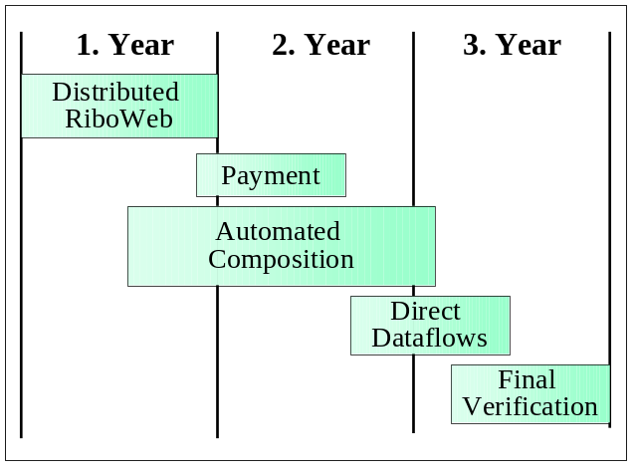
The MegaGeneS project will be subdivided into 5 subprojects: Distributed RiboWEB, Payment, Automated Composition, Direct Dataflows, and Final Verification.
In Distributed RiboWEB we will clarify into more detail the specific requirements of OWEB, integrate the CHAIMS protocol CPAM into RiboWEB, define and implement the concepts for the module repository, wrap a first set of remote computational modules, and enhance the RiboWEB user interface to perform manual pre-invocation cost estimation, incremental result extraction and progress monitoring. As the first year’s result, the new RiboWEB version will have remote computational modules and enhanced access and control features for these remote modules. Yet composition will still be manual, dataflows will always be routed over the client, and, though hidden by the user interface, the scientist will directly issue commands of the CPAM protocol.
The Payment subproject will be concerned with charging customers for their usage of remote services and with controlling maximum access times in educational environments. This will mainly imply enhancements to the wrappers of remote services, and will result in a further updated version of RiboWEB.
Automated Composition will be the biggest subproject. In it we will define an appropriate graphical composition language (VisiCLAM) based on the experience we have made thus with CLAM, and we will implement the necessary compiler and client engine to execute a composition defined by a megaprogram. The concepts for incremental composition will need to be refined further, the appropriate architecture has to be defined, and finally be implemented and tested. This subproject is by far the most complex and largest, as many of the issues have not yet been explored in depth. The existing compiler and the existing megaprogramming language CLAM are a good basis, yet they fall short for the requirements of incremental composition and graphical composition. Very important in this subproject will also be the participation of biological scientists, in order to architect and implement a composition facility within RiboWEB that will fulfill the expectations we have. The result of this subproject will be a version of RiboWEB that enables scientists to automatically compose computational modules and thus improve their efficiency. We expect to have first versions of RiboWEB supporting composition by the end of the second year, yet we understand that it will take several iterations to optimally support scientists in their work.
In Direct Dataflow we will enhance the compiler on the client side, the CPAM protocol and the wrappers so they can detect, control and handle direct dataflows between modules.
Though verification and dissemination of results is an ongoing process throughout the whole MegaGeneS project, special emphasis will be put on it during the Final Verification subproject. In case a DNA-CHIPweb has been developed at that point of time, MegaGeneS technology would also be deployed into that system. Also other deployments for all or part of MegaGeneS concepts and technologies will be considered and implemented if possible.

Management Plan
The MegaGeneS project will involve two university departments, the Department of Computer Science with principal investigator Prof. Gio Wiederhold and the Department of Medicine at Stanford with senior investigator Prof. Russ Altman. Since Prof. Gio Wiederhold and Prof. Russ Altman both hold courtesy appointments in each other’s departments and are already supervising students in both departments, we have the infrastructure and experience to manage the joint effort effectively. Dorothea Beringer, who has been managing the CHAIMS project, will be responsible as a research associate for the daily management and the supervision of student researchers from both departments. The fact that both departments involved in MegaGeneS are located in nearby buildings also simplifies the organizational aspects of the joint research effort.
Prof. Russ Altman is also involved with two other KDI proposals as a Co-PI and consultant. In “The Next Revolution in Scientific Publishing: Data and Models as Computer Interpretable Knowledge Bases”, he is working as Co-PI with Richard Fikes to create technology that will enable scientific research results to be published in the form of multi-use computer interpretable knowledge bases. In “Active Components for Knowledge Communities”, he is working with John Gennari to create mechanisms for annotating software with formal methods, in order to promote software reusability and to create data structures for storing collective knowledge about how to use software modules. The goals of these three grants are quite distinct and not overlapping. However, success of all three will enable him to work on bringing advanced knowledge and distributed intelligence technologies to biology, in three innovative and exciting ways.
A separate but related proposal, “BioWarehouse: Advanced Gathering, Query, and Search of Information in Structural Biology and Genomics”, is being submitted to KDI by Stanford Professors Widom and Garcia-Molina. They will focus on data-warehousing, i.e., large-scale, but static aspects. If both projects are funded, we expect to enable interoperation of information that can be effectively stored as well as computed at the best suited locality.

Dissemination of Results
There will be four main channels for the dissemination of the results:
- Publications: We expect to publish foundational insights concerning dynamic knowledge networking and the experiences gained by enhancing and applying CHAIMS to OWEB and using it in RiboWEB both in computer science and medical informatics venues. Ongoing progress will be available on public Web pages.
- Demonstrations to companies: There are many active companies in the Bay area that are interested in our approach. We plan to have demonstrations for these companies as well as for other industrial partners of Stanford University. We have both personal connections, often through former students, and linkages through industrial affiliates of Stanford University Computer Science and Medical Information Science forums. We expect some demos to be web-accessible. This will be a continuation of interaction that has been going on already during the last few years of megaprogramming research.
- Adoption by other research domains: The problems addressed by MegaGeneS and by OWEB are common to many research domains, and there is an ongoing exchange of ideas with other researchers outside of Stanford by the Department of Computer Science as well as the Section of Medical Informatics. A successful implementation and deployment in the context of RiboWEB will spark the interest in adopting the MegaGeneS technology as a whole or part of the concepts in other domains, as has been shown already by the interest from various groups for OWEB and CHAIMS technology.
- Students: Smart students are our most important product. We expect that students involved in the MegaGeneS project will later teach and disseminate these concepts, or be employed by bioinformatics or infrastructure companies that will address the conceptual and technical issues of composing distributed computational information sources. We also expect to involve some students on a purely academic basis.
We have been successful in prior dissemination of our research, and are confident that research this novel will find an appreciative audience.

Institutional Commitments
The Department of Computer Science, its Computer Systems Laboratory, and the InfoLab within them will provide the necessary office space as well as most of the software and hardware for the development work. The basic CHAIMS software infrastructure exists already. The laboratory currently has over 25 workstations and 7 servers of various types and manufacture. It has a network that provides very-high bandwidth interaction within the group and excellent Internet connections. Therefore the software can easily be developed on the computers of the InfoLab and then be ported to the production machines of the RiboWEB.
Staff for system maintenance is available. Necessary purchases covered by the award will mainly concern additional licenses for middleware systems. Yet we are often able to obtain hardware and software licenses at a substantial discount or as donations.

